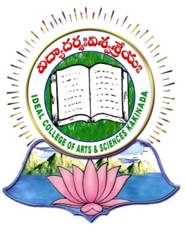 | IDEAL COLLEGE OF ARTS AND SCIENCES (A)
 | (A.P. Govt., Aided., Autonomous & NAAC B++)
 | Dr. P.V.N. RAJU VIDYAPRANGANAM
Samalkot Road, KAKINADA
East Godavari Dist
Andhra Pradesh

Department of Chemistry

Profile

- Name : R. Srinivasa Rao
- Designation and Place of work : Lecturer in Chemistry
Ideal College of Arts & Sciences (A)
Kakinada-533003
A.P., INDIA.
- Date of Birth : 24-04-1985
- Nationality : Indian
- Mobile no : 9703000626
- E-mail :
- Address for Correspondence : R.Srinivasa Rao
Lecturer in Chemistry
Ideal College Of Arts & Sciences,
Kakinada – 533 003, A.P., India.

- Details of Educational Qualifications:
Sl. No. | Course | University | Year | Specialization
1. | M.Sc | Andhra University | 2008 | Analytical Chemistry
2. | B.Ed | Andhra University | 2012 | Physical Science/Maths

- Experience:

Sl. No. | Designation | College | Date of Joining | Experience
1 | Part time Lecturer | Ideal college of Arts & Sciences Kakinada | 18-01-2011 | 5 years

- Administrative Experience:
Member in Admission committee

- Regional/ State/National and International level Conferences/Workshops/Seminars
- Two day National workshop on “Radiochemistry and applications of Radio Isotopes “ on 26 & 27 th February 2016 held at P.R. Govt. College , Kakinada in collaboration with Indian Association of Nuclear chemists & allied scientists(IANCAS)
- Rusa sponsored One day National Seminar on “Inter Disciplinary Aspects of Environmental Science” Held at Dr. Sarvepalli Radhakrishnan government Arts college, Yanam, (U.T. of Pudducherry) on 24 th February.
- Third Annual International Conferrence (AIC-3) Industry-CCRS Congress (ICC) 2015 held at B.R. Ambedkar University, Srikakulam, Andhra Pradesh on December 16 &17th 2015 Presented a paper “ Eco Friendly Technologies & Green Chemistry”

12. Research Work:
Published one research papers in International Journal.

